EXPERIMENT – 10

Title
IoT-Based Smart Agriculture and Automated Irrigation Using Soil Moisture Monitoring – Google Colab Simulation

Aim
To design and simulate an IoT-based smart agriculture system that monitors soil moisture and automatically controls irrigation based on a predefined moisture threshold using Python in Google Colab.

Apparatus / Software Required
- Google Colab
- Python 3
- Random library
- Matplotlib library

Objectives
To simulate soil moisture sensor readings, monitor the moisture level of soil, automatically turn irrigation ON when the soil moisture is below the threshold value, turn irrigation OFF when sufficient moisture is available, and visualize the soil moisture readings using a graph.

Theory
IoT-based smart agriculture uses sensors and automated control systems to improve agricultural activities. Soil moisture sensors can measure the amount of moisture present in the soil and help determine when irrigation is required.
In this experiment, soil moisture readings are randomly generated to simulate a soil moisture sensor. A threshold value of 40% is used for irrigation control.
- If soil moisture < 40%, irrigation is ON.
- If soil moisture ≥ 40%, irrigation is OFF.
The system monitors multiple readings and displays the irrigation status for each reading. A graph is also generated to visualize the variation in soil moisture.

Algorithm
- Start the program.
- Import the required Python libraries.
- Initialize an empty list to store soil moisture readings.
- Set the number of readings to 10.
- Generate a soil moisture value for each reading.
- Compare the moisture value with the 40% threshold.
- If moisture is below 40%, turn irrigation ON.
- Otherwise, keep irrigation OFF.
- Display the soil moisture value and irrigation status.
- Store all moisture readings.
- Plot the soil moisture readings.
- Display the 40% irrigation threshold on the graph.
- Count the number of times irrigation was ON and OFF.
- Display the irrigation summary.
- Stop the program.

Procedure
- Open Google Colab and create a new Python notebook.
- Import the random and matplotlib.pyplot libraries.
- Initialize the soil moisture list.
- Set the number of readings to 10.
- Generate simulated soil moisture readings.
- Compare each reading with the 40% threshold.
- Automatically determine the irrigation status.
- Display each reading and its irrigation condition.
- Generate the soil moisture monitoring graph.
- Display the irrigation threshold on the graph.
- Calculate the total number of ON and OFF irrigation conditions.
- Display the final irrigation summary.
- Observe the output and graph.

Parameters Used
Parameter | Value
Sensor Parameter | Soil Moisture
Unit | Percentage (%)
Number of Readings | 10
Irrigation Threshold | 40%
Moisture < 40% | Irrigation ON
Moisture ≥ 40% | Irrigation OFF

Sample Data
Reading | Soil Moisture (%) | Irrigation
1 | 35 | ON
2 | 52 | OFF
3 | 28 | ON
4 | 65 | OFF
5 | 42 | OFF
6 | 31 | ON
7 | 70 | OFF
8 | 38 | ON
9 | 55 | OFF
10 | 45 | OFF
Phton code:
# ============================================
# IoT-Based Smart Agriculture
# Automated Irrigation using Soil Moisture
# Google Colab
# ============================================

import random
import matplotlib.pyplot as plt

print("=" * 55)
print(" IoT-BASED SMART AGRICULTURE SYSTEM")
print("=" * 55)

# Soil moisture readings (%)
soil_moisture = []

# Number of readings
readings = 10

# --------------------------------------------
# Soil Moisture Monitoring
# --------------------------------------------

for i in range(1, readings + 1):

moisture = random.randint(20, 80)
soil_moisture.append(moisture)

# Irrigation control
if moisture < 40:
irrigation = "ON"
else:
irrigation = "OFF"

print(
"Reading", i,
"| Soil Moisture =", moisture, "%",
"| Irrigation =", irrigation
)

# --------------------------------------------
# Graph
# --------------------------------------------

reading_numbers = list(range(1, readings + 1))

plt.figure(figsize=(9, 5))

plt.plot(
reading_numbers,
soil_moisture,
marker="o"
)

# Moisture threshold
plt.axhline(
40,
linestyle="--",
label="Irrigation Threshold"
)

plt.title("Soil Moisture Monitoring")
plt.xlabel("Reading Number")
plt.ylabel("Soil Moisture (%)")
plt.legend()
plt.grid(True)

plt.show()

# --------------------------------------------
# Final Summary
# --------------------------------------------

irrigation_on = sum(
1 for value in soil_moisture if value < 40
)

irrigation_off = readings - irrigation_on

print("\n" + "=" * 55)
print(" IRRIGATION SUMMARY")
print("=" * 55)

print("Total Readings :", readings)
print("Irrigation ON :", irrigation_on)
print("Irrigation OFF :", irrigation_off)

print("\nSmart Irrigation Monitoring Completed Successfully!")
print("=" * 55)

Graph
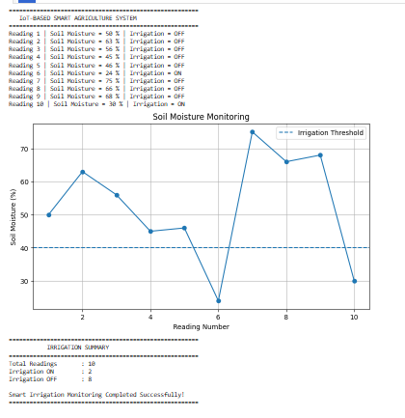

Result
The IoT-Based Smart Agriculture and Automated Irrigation System was successfully simulated using Python in Google Colab. Soil moisture readings were monitored and irrigation was automatically switched ON when the moisture level was below 40% and OFF otherwise. The soil moisture variations were successfully visualized using a graph.

